ENGLISH FIRST ADDITIONAL LANGUAGE
GRADE 10 – PAPER 1
JUNE 2010
TIME: 2 HOURS
MARKS: 70

INSTRUCTIONS
- This paper consists out of: SECTION A – Comprehension
SECTION B – Summary
SECTION C – Language
- Answer all the questions.
- Begin the answer to each SECTION on a NEW page.
- Leave a line open between each answer.
- Number your answers according to the numbering system used in the question paper.
- Staple your question paper to the back of your answer sheets after you have finished.
- Write neatly and legibly.
- In Section C marks are deducted for spelling mistakes.

SECTION A – COMPREHENSION
QUESTION 1
Read the following passage and answer the questions that follow:

Some time during April a history research student from the University of the Witwatersrand, Eric Axelson, gave a lecture on his solution to a problem that had puzzled South African historians for many years.
The problem seemed simple: where, precisely, did Bartholomew Diaz – the first man to round the Cape – plant a padrao, the last of a series of stone crosses, before his mutinous crew compelled him to give up his attempt to reach India? All trace of it had disappeared.
Axelson’s solution had been to re-examine the earliest accounts of his voyage, which stated specifically that the cross had been planted on an ‘ihla’, which previous scholars had taken to mean an island, and so had been forced to look for the nearest island compatible with our evidence. They looked in vain. Axelson, however, discovered that ‘ihla’ could mean headland; and there was a headland called Kwaai Hoek five kilometres to the west of the Bushmen’s River Mouth which seemed to tally entirely with the other evidence. Besides, between this headland, (consisting, in fact, of three rocky knolls with cliffs fronting the breakers) and the dark green coastal bush was a fine stretch of low white sand dunes, which would sink out of sight a few miles out to sea, leaving the headland to ride the sea’s horizon like an island indeed.
So he went to search the site, where nothing was visible through the mat of dune scrub. The break-through came when, at low tide, he and his brother started exploring the rock pools at the base of the cliff. Here they found large cigar-shaped object obviously harder than the local stone which, rocked by the sea through four-and-a-half centuries, had cut a cradle for itself. Other fragments were found.
Analysis by Professor Edgar Mountain, our Professor of Geology, showed that the rock was a limestone unknown to Africa. Later it was established that it came from Portugal. Certain of the fragments were rectangular in shape; some showed clear signs of incised gothing lettering, but too worn to be decipherable.
Axelson’s lecture and discovery were important to me because Diaz had already a vague symbolical significance for me. I had always found him an attractive figure, not merely because he ‘was the first that ever burst into our silent sea’ but because of a certain tragic irony, if not grandeur, in his subsequent career. He was not given credit for doubling* the Cape; neglected, relegated to an insignificant command, he and his ship disappeared without trace in an Atlantic storm; so that it might indeed seem that the curse of Adamastor (that mythical Titan invented by Camoens) had fallen on the man who unlocked the African coastline and, in due course, much of the interior of the continent, to Europe.
(Guy Butler:Bursting World)
* “doubling” – a nautical term meaning “to sail around a headland”.

  - Choose the correct answer. Write the letter of your choice (A-D) next to the number of the question (1.1) in your answer book. What question did Eric Axelson explore?

- Was Bartholomew Diaz the first explorer to round the Cape?
- Where exactly did Diaz place his last stone cross?
- Did Diaz abandon hit attempt to reach India because of his mutinous crew?
- Was Diaz given credit for his explorations?
(1)
1.2 Choose the correct answer. Write the letter of your choice (A-C) next to the number of the question (1.2) in your answer book. Axelson concluded that the cross had been planted on:

- A headland
- An island
- A dune.
(1)
1.3 Choose the correct answer. Write the letter of your choice (A-C) next to the number of the question (1.3) in your answer book. The remains of the cross were found

- Under bushy scrubland
- On a cliff
- In rock pools
(1)

1.4 Choose the correct answer. Write the letter of your choice (A-C) next to the number of the question (1.4) in your answer book. Analysis of the stone fragments found showed that they were

- Of African origin.
- Not authentic.
- Of Portuguese origin.
(1)
1.5 Choose the correct answer. Write the letter of your choice (A-C) next to the number of the question (1.5) in your answer book. Diaz was of particular interest to Butler because

- He was a great navigator
- He seemed to fulfill the prophecy of a curse
- He opened up much of the continent of Africa.
(1)
1.6 Choose the correct answer. Write the letter of your choice (A-C) next to the number of the question (1.6) in your answer book. Incised gothic lettering means

- Frightening teeth-like shapes
- An ancient alphabetical form
- Fifteenth-century letters cut into stone
(1)
1.7 Choose the correct answer. Write the letter of your choice (A-C) next to the number of the question (1.7) in your answer book. Axelson’s field of research was

- Archaeology
- Geology
- History
(1)
1.8 Choose the correct answer. Write the letter of your choice (A-C) next to the number of the question (1.8) in your answer book. The type of stone found was pronounced to be

- Granite
- Limestone
- Marble
(1)
1.9 Choose the correct answer. Write the letter of your choice (A-C) next to the number of the question (1.9) in your answer book. The gothing lettering on the stone …

- Solved a long-standing mystery.
- Could not be made out
- Was easily read
(1)
1.10 Choose the correct answer. Write the letter of your choice (A-C) next to the number of the question (1.10) in your answer book. How did Diaz’s career end?

- With grandeur
- Tragically
- Quietly
(1)
1.11 Who wrote this extract and what is the name of the book that it is from?
(2)
1.12 What is a padrao?
(1)
1.13 What did earlier students believe the meaning of ‘ihla’ was?
(1)
1.14 Say whether the following statement is TRUE or FALSE. Quote a phrase to substantiate your answer.
The headland looked like an island.
(2)
1.15 What is the meaning of the expression “doubling the Cape”?
(1)
1.16 Why did the writer use a hyphen in the word “re-examine” (par 3)?
(1)
1.17 Find the word form the passage of opposite meaning for complicated (par. 2)?
(1)
1.18 How many years are there in four-and-a-half centuries?
(1)
1.19 How do you think would a ‘mutinous crew’ behave?
(2)
1.20 How did the career of Diaz end?
(2)
1.21 How did people know that Diaz planted a cross somewhere?
(1)
[Total Section A: 25]

SECTION B – SUMMARY
QUESTION 2
Refer to the passage below. You have to tell your class briefly about Mind Power Coursers. You can mention 7 facts that you picked up from the article MIND POWER COURSES. Write down the seven facts that you will use in point form. Number your facts 1-7. You may use only 70 words. Indicate the number of words you have used. Write down the heading of the summary.

The title of your talk would be: What I know about Mind Power Courses.

MIND POWER COURSES

Whose mind? What power? It’s about learning how to use the powers of your mind in order to improve yourself – by loosing weight, quitting smoking, being miserable – and turning yourself into a slim, healthy, rich, attractive and spiritually holistic winner.
The path to the mind power course is a busy one – clogged with other seekers and travellers. The world and his mother, it seems, are on a “journey” to a quick fix. And along the way some (unwise souls) would also like to unpack emotional baggage from the past.
The wise are weary of the mind power courses that they choose. After all, it’s a free world and, as a certain Canadian mind power guru says, ‘Anybody can hang a sign outside his door and Bingo, he’s in business. It’s a wild world out there and, like the Wild West, you get the good, the bad and the ugly.’
Seems he’s one of the good. Why else on a Highveld winter’s night, would nearly 2000 people cram into a massive hall on two consecutive nights, to hear him speak in a free introductory seminar?
What’s the attraction of a slightly paunchy, middle-aged man to the hundreds who came to hear him talk? Perhaps it’s the opportunity to tap into the 90 per cent of our minds that we’re not using.
An Australian accountant-turned-psychologist evokes the same reaction on his Alpha Mind Power course when he tells that our minds can store as much information as the millions of volumes in the British Museum Library without any strain at all. It’s the lure of using all those cells that attract such large numbers.
The point is you pay – big time! Anything from R2500 to R5780 for a course. Do you get your money’s worth? That depends on whether you acquire skills or insight – and whether you practise the mind power exercises.
On the whole, a leading Clinical Psychologist believes that most courses ‘stimulate awareness – the first step to change – and could pleasantly surprise the majority of people who want to develop some insight.’ However, there is also a downside. Even though the course are filling a need, they do rush the process of developing the mind. Further, the learning is done in a group and where there have to be follow –up exercises.
[Total Section B: 10]

SECTION C – LANGUAGE
Question 3 – Visual Literacy
Study the following visual text (cartoon) closely and answer the questions that follow:
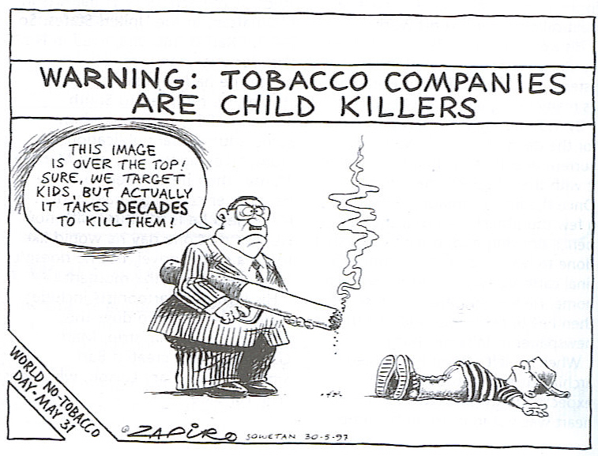

3.1 What is the cigarette a symbol of?
(1)
3.2 Write down the Standard English word for “kids”.
(1)
3.3 How many years are in a “decade”?
(1)
3.4 Who or what does the man in the suit represent?
(1)
3.5 Why are the words spoken by the man in the suit, ironic?
(2)

Look at the following advertisement and answer the questions that follow:


3.6 What is this bus advertising?
(1)
3.7 What does the images on the bus suggest about the product?
(3)
3.8 What is the name of the company that manufactures the product?
(1)
3.9 Give one reason why you think this advertisement on the bus might be effective?
(1)
3.10 What figure of speech is used in the cartoon below? Choose the correct answer (A-D) and write it next to the correct number (3.10) in your answer book.

- Hyperbole
- Litotes
- Antithesis
- Metonymy

(1)

3.11 What figure of speech is used in the cartoon below? Choose the correct answer (A-D) and write it next to the correct number (3.11) in your answer book.
A. Litotes
B. Malapropism
C. Oxymoron
D. Antithesis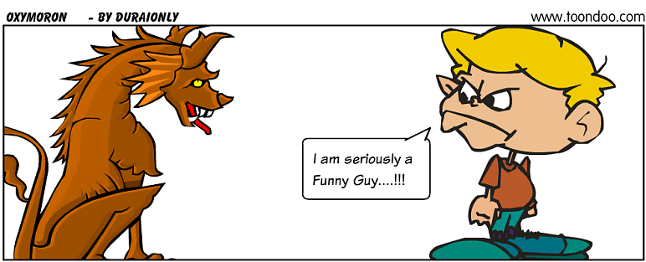
(1)
3.12 What figure of speech is used in the cartoon below? Choose the correct answer (A-D) and write it next to the correct number (3.12) in your answer book.

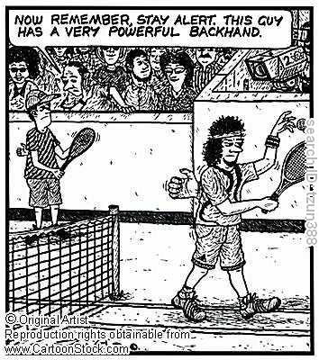
- Hyperbole
- Pun
- Metaphor
- Innuendo
(1)

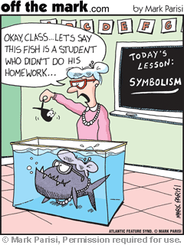
3.13 What figure of speech is used in the cartoon below? Choose the correct answer (A-D) and write it next to the correct number (3.13) in your answer book.
A. Simile
B. Irony
C. Metaphor
D. Contrast
(1)
[15]
QUESTION 4 – LANGUAGE AND EDITING

4.1 Dictionary work: look at the following dictionary entry and answer the questions that follow:

Fry cook A. /fraı/ verb [I or T] to cook food in hot oil or fat: Fry the mushrooms in a little butter. ○ INFORMAL FIGURATIVE You’ll fry (=burn) if you lie in the sun all day.
Fried /fraıd/ adj cooked in hot oil or fat: a fried egg ○ fried onions
Fryer, frier /’fraı.ə^{r}/ noun [C] 1 a large deep pan in which food is fried: I’ve just bought a deep-fat fryer for cooking chips
Fry fish / fraı/ plural noun young , small fish
Frying pan A. noun [C] a flat metal pan with a long handle which is used for frying food
• Out of the frying pan into the fire. SAYING said when you move from a bad or difficult situation to one which is worse
Fry-up /’fraı.up/ noun [C] UK INFORMAL a meal consisting of fried meat, eggs and vegetables.

4.1.1 Write down the denotation of ‘fry’.
(1)
4.1.2 Write down the connotation of ‘fry’.
(1)
4.1.3 Use the word “fry” as a noun in a sentence.
(1)
4.1.4 Use the word “fry” as a verb in a sentence.
(1)
4.1.5 What is the meaning of the expression “Out of the frying pan into the fire”?
(1)[5]
4.2 The following passage has deliberate language mistakes in them. Read the passage and answer the questions that follow:

Youths learn from Uganda
Eight youth delegates/delecates from the Amathole District Municipality (AMD) were warmly welcomed this week when they returned from Uganda. The delegates/delecates were selected after the ADM signed an agreemant with the Ugandan Central Divisional Councel/Council because they are knowledgeable about Small, Medium and Micro Enterprise development.
One of the delegates/delecates said that they have a lot from Uganda learnt: amongst other things they had learnt how to welding and dough machines make and a cooker solar.
One delegate/delecate said: “I was/were so impressed with how the solar cooker was made. It only uses aluminium foil to take in sunlight. Food cooked on it was ready within an hour.!” The ADM executive mayor told the youth that they had a responsibility to apply what they had learnt in their own small busineses because the young/youth are the drivers of the economic growth in the region.

4.2.1 Which word is the correct word to use in this passage: delegate or delecate?
(1)
4.2.2 There is one punctuation error in this passage. Write down the sentence with the correct punctuation that should have been used.
(2)
4.2.3 Which word is the correct word to use in this passage: young or youth?
(1)
4.2.4 Which is the correct spelling: councel or council?
(1)
4.2.5 Look at the words: small, medium and micro. Which word indicates the smallest volume?
(1)
4.2.6 The word order of one of the sentences are muddled. Write down the sentence with the correct word order.
(4)
4.2.7 Take the statement “Youths learn from Uganda” and change it into a question.
(2)
4.2.8 Which word is the correct word to use in the passage: was or were?
(1)
4.2.9 There are two misspelled or incorrectly used words in the passage that has not been indicated. Find them and write down correct words.
(2)
[15]
Total for Question 4: 20
Grand Total for Paper 1: 70

